Aaron Eberly

Week 3 CNIT 15501

Naming Variables

Illegal variable names:

* Can’t have spaces.
* Can’t start with a number
* Can’t include math operations (such as - + / *)

Examples:

firstName GOOD

first name BAD because it has a space

1firstName BAD because it starts with a number

_first_name GOOD

Math Operations

Exponent: ** Example: 4** 2 = 16

Modulus (%) gives the remainder. Example: 5 % 2 = 1

Other functions:

IMPORTANT: If you want to use the functions on the below table, you must put the following line in your code:

import math

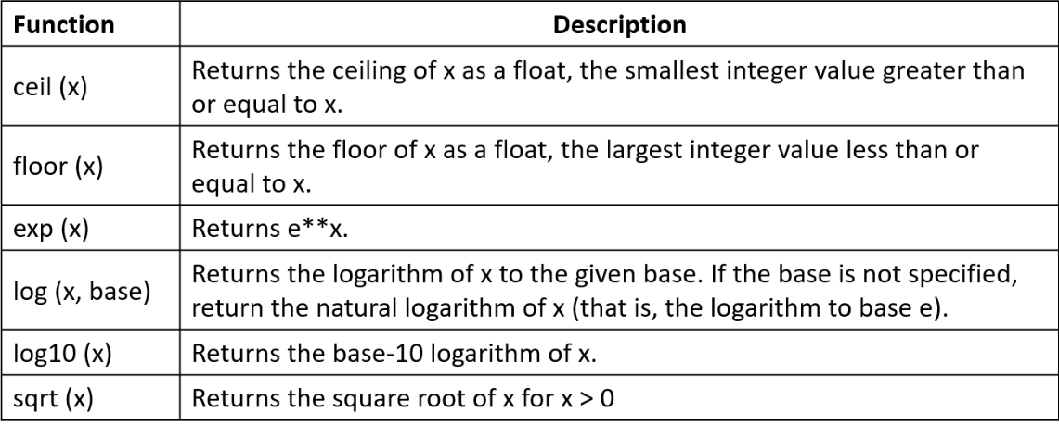

abs(x) gives the absolute value of x.

len(x) will give the length of a string or list.

min(x) gives the lowest number in a list.

max(x) gives the highest number in a list.

math.ceil(x) rounds up

math.floor(x) rounds down

Examples:

abs(-2) = 2

len (“CNIT 15501”) = 10

min(3, 5, 2, -2, 0) = -2

IMPORTANT: remember PEMDAS when doing math operations.

PEMDAS review: 1. Parenthesis, 2. Exponents, 3. Multiplication and division, 4. Addition and subtraction

Example:

40 / (13 - 8) ** 2

40 / 5 ** 2

40 / 25

1.6

Conditionals

if statements: This statement offers branching paths, based on whether the statement is true.

else: Resolves if the if statement is false.

Example:

If (x == 1):

print(“Hello”)

else:

print(“Goodbye”)

In the above code, if x is equal to 1, the code will print “Hello”. If x is not equal to 1, then it will print “Goodbye”.

NOTE: You must use == instead of just = when using if statements!

If you want to check multiple conditions, you can use elif.

Example:

If (x == 1):

print(“Hello”)

elif (x == 2):

print(“Goodbye”)

elif (x == 3):

print(“Have a nice day!”)

else:

print(“Have a good night!”)

So what does this print? If x = 1, it will print “Hello”. If x = 2, it will print “Goodbye”. If x = 3, it will print “Have a nice day!”. If x is anything except for 1, 2, or 3, it will print “Have a good night!”.

Three Boolean operators: and, or, not

An and statement is true if both inputs are true

An or statement is true if one of the inputs is true

A not statement is true if the input is false

Random Numbers

First, you must use the following line of code. You only need to use this line of code once:

import random

Then, you can use random.randomrange(x, y)

For example, the following line will return a number between 1 and 10:

Random.randrange(1, 11)

NOTE: notice the upper bound is 11 instead of 10. The number returned will always be EQUAL TO OR GRESTER THAN the lower bound, and it will be LOWER than the upper bound.

Reminders

Type casting: When you change the type of a variable

Comparing numbers:

Greater than: >

Less than: <

Greater than or equal to: >=

Less than or equal to: <=